System Design Document
V1.0

Overview
The Arduino Urban Kitchen Garden Project is an Open Source Arduino controlled counter-top garden for growing vegetables, herbs, or greens for sustainable foods right in your own home. The project is shared with the world in hopes of more people enjoying the ability to grow food at home as well as taking the design forward in the open-source community.

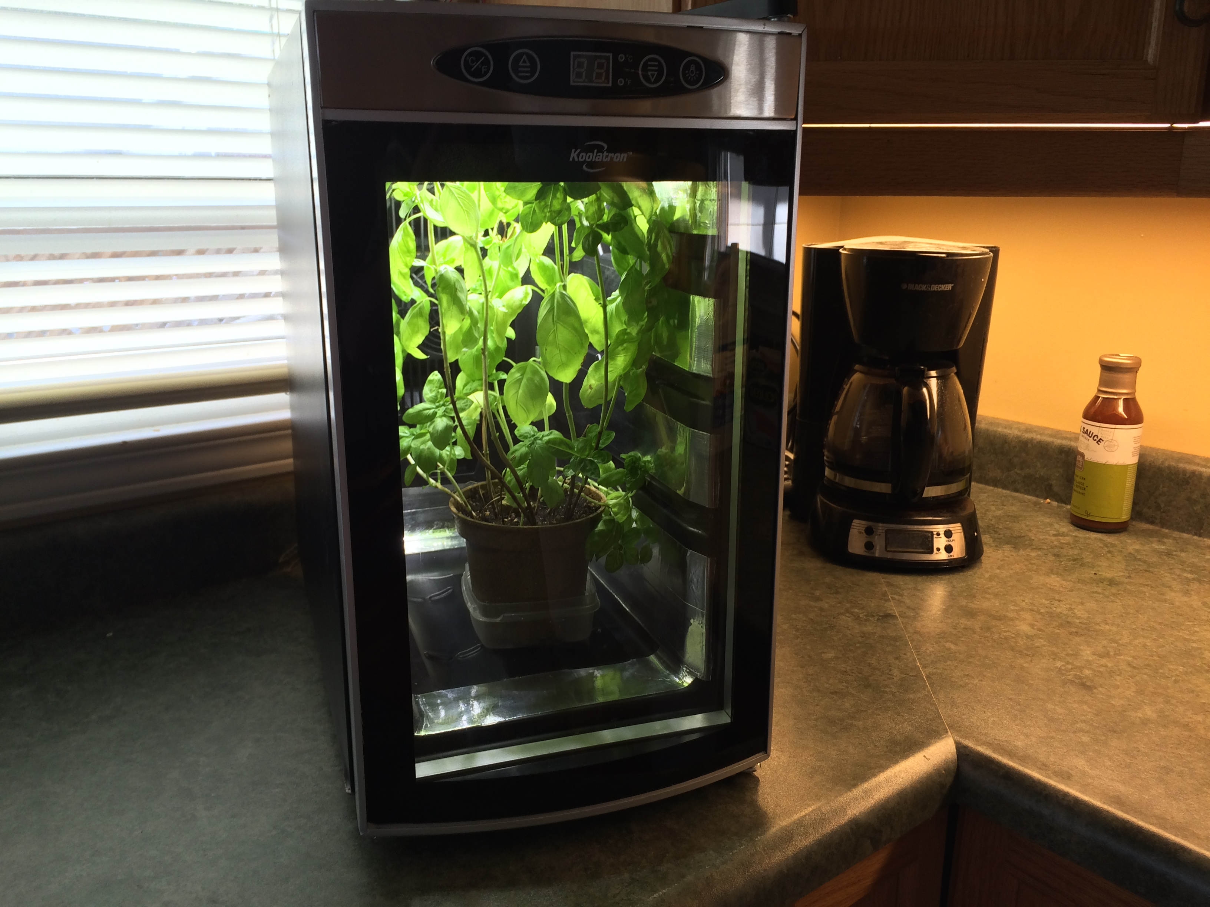

INTRODUCTION

Purpose and Scope
The Urban Kitchen Garden takes any peltier driven cooler and transforms it into a chamber custom suited for growing any type of plant. It provides full control and monitoring of variables such as temperature, light cycles and more

Project Executive Summary
The project is open to all user modification and improvements. At its core the microcontroller and code provide direct control over all growing chamber variables whereby enabling optimal plant growth within the chamber.

System Overview
The Arduino Nano micro controller is utilized by uploading the provided code (requires the supporting libraries). The micro controller monitors the relevant signals and controls the outputs as dictated by variables in the code.

Chamber cooling is supplied by the original pelitier thermo-electric cooler (TEC). Overall system power is provided by a basic 12 volt DC power supply.

Lighting for the plants is provided by an LED fixture but this can be substituted with any light source the user desires such as compact fluorescent, incandescent, cold cathode etc.

Soil/grow media moisture monitoring is implemented via a soil moisture probe providing input to the micro controller.

Alarms are triggered for any value outside intended range and user is alerted via the LCD display panel.

Full Overview Video:
https://www.youtube.com/watch?v=YZIATF9IRiY

Design Constraints
Libraries used in the code have specific license requirements. User must ensure these are not violated.

Wire.h Library:
No specific notes exist but falls under Creative Commons Attribution-ShareAlike 3.0 License

DHT.h Library:
MIT License. Written by LadyAda Public Domain

Adafruit_GFX.h Library:
Software License Agreement (BSD License)

Copyright (c) 2012 Adafruit Industries. All rights reserved.

Redistribution and use in source and binary forms, with or without
modification, are permitted provided that the following conditions are met:

- Redistributions of source code must retain the above copyright notice,
this list of conditions and the following disclaimer.
- Redistributions in binary form must reproduce the above copyright notice,
this list of conditions and the following disclaimer in the documentation
and/or other materials provided with the distribution.

Adafruit_PCD8544.h Library:
Software License Agreement (BSD License)

Copyright (c) 2012, Adafruit Industries
All rights reserved.

Redistribution and use in source and binary forms, with or without
modification, are permitted provided that the following conditions are met:
1. Redistributions of source code must retain the above copyright
notice, this list of conditions and the following disclaimer.
2. Redistributions in binary form must reproduce the above copyright
notice, this list of conditions and the following disclaimer in the
documentation and/or other materials provided with the distribution.
3. Neither the name of the copyright holders nor the
names of its contributors may be used to endorse or promote products
derived from this software without specific prior written permission.

Future Contingencies
NA at this time

Document Organization
NA

Points of Contact
Support provided via the forum at http://mkme.org as well as the GIT repository.
https://github.com/MKme/Urban-Kitchen-Garden

Support for the libraries used to support the code is provided by the original authors only. Restrictions for use can be found on their respective support pages (linked within the Arduino Source Code)

Forum Thread:
http://mkme.org/forum/viewtopic.php?f=4&t=695

Project References
Initial design completed fall 2014. Testing and updates completed through spring 2015 at which point the project was fully released via Hackaday website:

https://hackaday.io/project/6324-urban-kitchen-garden

Glossary
Arduino- Arduino is an open-source computer hardware and software company, project and user community that designs and manufactures microcontroller-based kits for building digital devices and interactive objects that can sense and control the physical world.

The project is based on a family of microcontroller board designs manufactured primarily by SmartProjects in Italy, and also by several other vendors, using various 8-bit Atmel AVR microcontrollers or 32-bit Atmel ARM processors. These systems provide sets of digital and analog I/O pins that can be interfaced to various expansion boards ("shields") and other circuits. The boards feature serial communications interfaces, including USB on some models, for loading programs from personal computers. For programming the microcontrollers, the Arduino platform provides an integrated development environment (IDE) based on the Processing project, which includes support for C,C++ and Java programming languages.

TEC- Thermo Electric Cooler

LED- Light Emitting Diode

SYSTEM ARCHITECTURE
Arduino Nano (Atmel) provides overall control and monitoring of the garden systems.

System Hardware Architecture
- Arduino Nano- The Arduino Nano is a small, complete, and breadboard-friendly board based on the ATmega328 (Arduino Nano 3.x) or ATmega168 (Arduino Nano 2.x). It has more or less the same functionality of the Arduino Duemilanove, but in a different package. It lacks only a DC power jack, and works with a Mini-B USB cable instead of a standard one. The Nano was designed and is being produced by Gravitech

- 8 Bottle Wine Cooler- Provides the enclosure and cooling systems.

- Nokia 5110 LCD- Provides user interface display for all relevant parameters

- DHT11 Sensor- Provides humidity and temperature values from the grow chamber

- Tiny RTC Module- The real time clock module provides accurate date/time keeping for proper code execution and light cycles.

- Soil Moisture Sensor- Provides reading of moisture in the grow media (soil)

- Relays- Basic 12V relays provide control of the lights and cooling systems

- LED lights- provide energy/light for plant growth

- 12VDC Power Supply- Provide power for all systems on board.

- 12 VDC Fan- Cooling of LED lighting.

System Software Architecture
- loop()- All code execution

- TimeFunctions()- All code relying on time function executed here. Executes reading of date/time from RTC, activation of lighting, deactivation of lighting and more if user desires

- TempFunctions()- All code relating to temperature executed here. Reads temperature and humidity from chamber sensor and executes commands to turn the cooling on or off depending on value

- SoilMoisture()- Read soil moisture temperature value and store to variable. Sets the status to Dry, Wet or Moist depending on value received

- Debug() – Self explanatory for debugging purposes

- LCDDisplay()- Display all values to the LCD screen for visual display to user/operator.

- Alarm()- Determines if alarm criteria have been met such as over/under temperature condition in the grow chamber.

- DisplayFlash()- Flash the LCD display if ANY alarm criteria have been met.

Internal Communications Architecture
Serial bus between Arduino and Nokia 5110 using SPI.

FILE AND DATABASE DESIGN
All files and updates via GitHub:

https://github.com/MKme/Urban-Kitchen-Garden

Database Management System Files
- NA

Non-Database Management System Files
- NA

HUMAN-MACHINE INTERFACE
LCD display provides specific data to the user via a continually updated menu.

- Date/Time
- Soil Moisture Level
- Soil Moisture RAW Value
- Lighting State
- Chamber Temperature
- Chamber Relative Humidity Value
- Cooling State

Inputs
- All values and limits are entered directly into the code in the identified areas (heavily commented)

Outputs
- All outputs are defined in the code

DETAILED DESIGN
NA

Hardware Detailed Design
- NA

Software Detailed Design
- NA

Internal Communications Detailed Design
- NA

EXTERNAL INTERFACES
NA

Interface Architecture
NA

Interface Detailed Design
NA

SYSTEM INTEGRITY CONTROLS
NA

